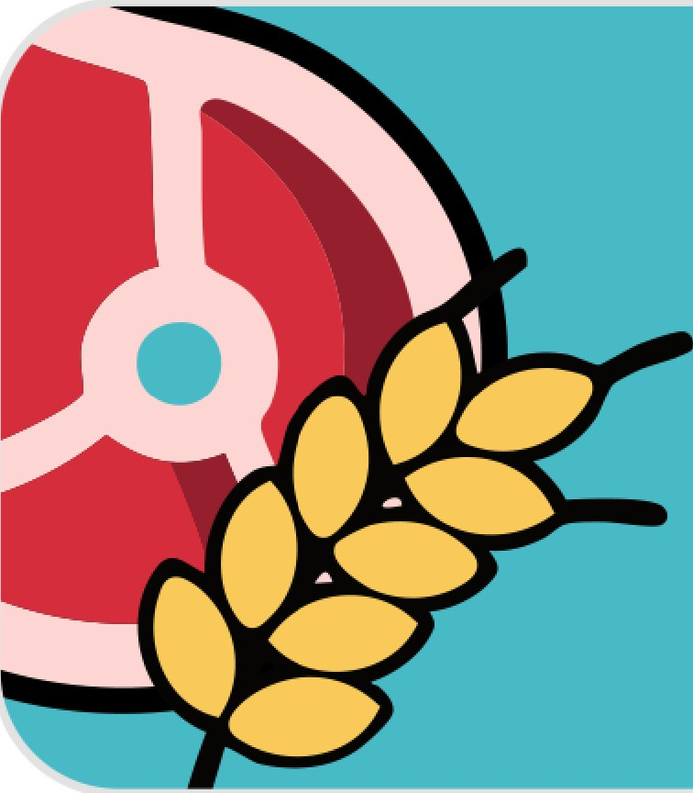
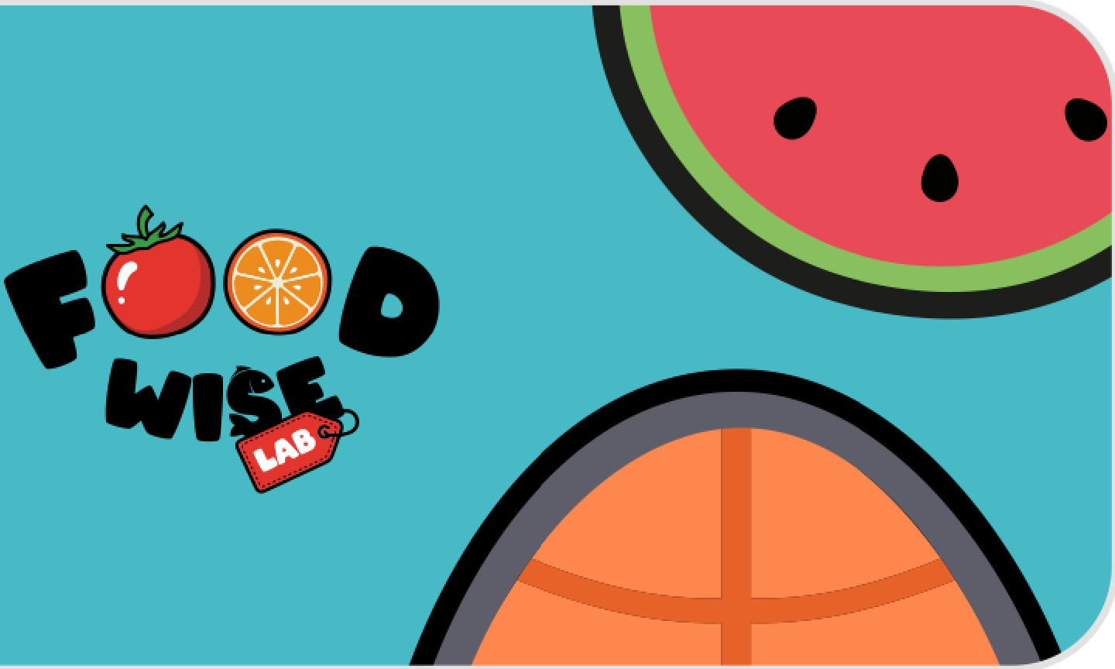

SCHOOL-FAMILY ACTIVITIES | 12–14 YEARS OLD
PLAN I As a family
- The challenge "What do we already have at home?"
Objective: to reduce waste and plan consciously.
How to make:
  - As a family, open the fridge and pantry.
  - List 5 foods that already exist.
  - Think together: What simple meals can we make with this?
  - Choose 1 meal of the week that will be made primarily with these foods.

- Game "Before buying, thinking"
Objective: to develop anticipatory thinking.
How to make:
  - Before going shopping, each person answers:
    - What do we really need?
    - What is usually left?
    - What spoils faster?
  - At the end of the week, talk 5 minutes:
    - What went well?
    - What could have been avoided?
SELECT I In family
- The Spoken Label

Objective: food literacy without testing.
How to make:
  - Choose a usual household product.
  - An adult reads the label aloud.
  - The young person answers orally:
    - What do I recognize?
    - Did something surprise me?
    - Would we buy again? Why?
- The invisible origin
Objective: to connect choices to the territory.
How to make:
  - Choose 3 foods of the day.
  - Try to answer together:
    - Do they come from near or far?
    - Are they from the season?
    - How did they get to us?
Optional: mark on a simple map (paper or digital).

PREPARE I As a family
- Cooking as a team (without a stove) Objective: safety, organization and sharing.
How to make:
  - Prepare a simple meal or part of it (salad, cold soup, sandwiches).
  - Divide tasks:

    - wash,
    - cut,
    - organize,
    - fix at the end.
  - At the end, talk:
    - What was most important for everything to go well?
- The keeper of the refrigerator
Objective: conservation and waste.
How to make:
  - A young person is responsible for:
    - check older foods,
    - warn of approaching deadlines,
    - suggest ways to take advantage of it.
Duration: 1 week.
EAT I As a family
- The meal without screens (experience) Objective: mindfulness and conviviality.
How to make:
  - Choose a meal of the week without screens.
  - At the end, each person answers:
    - What did I notice that was different?
    - Did I eat slower?
    - Did I talk more?
- The colours of the plate

Objective: food variety without counting.
How to make:
  - Observe the main meal course.
  - Count different colours.
  - Challenge: Can we add one more colour tomorrow?
ONE HEALTH I In the family
- Connections at home
Goal: to make One Health concrete.
How to make:
  - Choose a situation in the house (e.g., waste, water use, choice of food).
  - Reply together:
    - How does this affect our health?
    - Does it affect animals?
    - Does it affect the environment?
No right answers –guided conversation only.
MEDITERRANEAN DIET I In the family
- A tradition at the table
Objective: to connect culture, food and identity.
How to make:
  - Prepare or talk about a traditional family dish.
  - Talk:
    - When do you eat?
    - Who usually prepares?
    - What does it represent?

